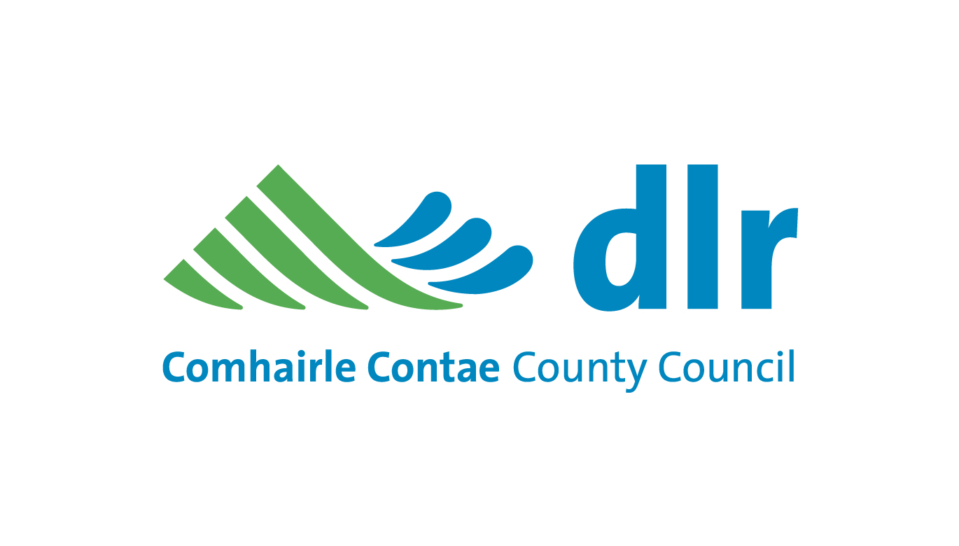
UPDATE OF DETAILS IN RELATION TO YOUR
APPLICATION FOR SOCIAL HOUSING SUPPORT
- Please complete the following form to update your application for social housing with Dun Laoghaire-Rathdown County Council.
- Please post your updated form to DLRCC, Housing and Community Department, County Hall, Marine Road, Dun Laoghaire OR bring the form into the Council offices at either Dun Laoghaire or Dundrum by Thursday 14th July 2016.

Please answer the following questions:
Housing list reference number
(on attached letter)

Are you still interested in being on the Social Housing Support List? (tick box) | 
Do you have an application with any other local authority? (tick box)  If yes please give details. | Local Authority Name:

Office Use Only
Logged: | Updated:

Your details (please write in the following and tick where indicated)
Full name
Email address
Phone number
PPSN:__________________ | Gender: Male ____ Female ____
Civil status (please tick) | 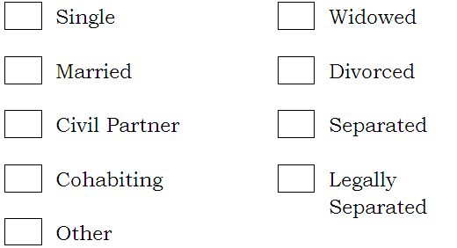
Employment status (please tick the box which applies to you)
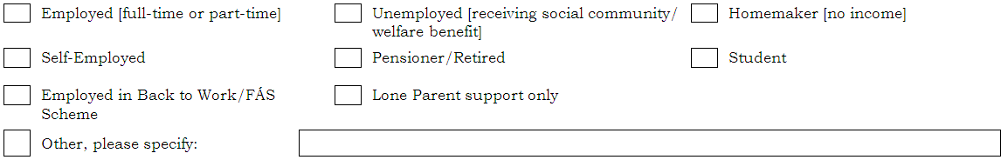
Please tick the box which best describes your current living arrangement:
 | Private rented accommodation:    

 | 
__________________________________________________________

Your partner /spouse’s details (please write in the following and tick where indicated)
Full name
Email address
PPSN: | Gender: Male ____ Female ____
Phone number
Employment status (please tick the box which applies to you)

Please answer the following questions:

Since you applied for Social Housing Support have any of the following changed – (we do not require previously submitted information)

Has anybody joined the household?
If yes please give details at question 1
(on page 4)
Has anybody left the household?
If yes please give details at question 2.
(on page 5)
Has there been any change in employment status/income?
If yes please give details at question 3.
(on page 5)
Does anyone in the household have a disability or medical condition?
If yes please give details at question 4.
(on page 6)
Have you changed address and not informed us?
Please give details at question 5.
(on page 7)
Do you own any land or property?
If yes please give details at question 6.
(on page 8)
Do you reside outside the County of Dublin?
If yes please answer question 7.
(on page 8)
If you have ticked NO for all of the above please sign here and return form to Council Offices (address on page 1): | Name: ________________________  Name: ________________________  Date: ________________________

Q 1. Has anybody joined the Household?

Details (please write in the following or tick where indicated)

Name 1:
Date of Birth
PPSN
Relationship to yourself e.g. partner, spouse, child, etc.
Civil status of person
(please tick)
Employment status (please tick the box which applies to the Joint Applicant)
Citizenship Status: Irish ______ EEA:_______ Non EEA:_________
If Non EEA Basis of Stay in Ireland: _______________________________

Name 2:
Date of Birth
PPSN
Relationship to yourself e.g. partner, spouse, child, etc.
Civil status of person
(please tick)
Employment status (please tick the box which applies to the Joint Applicant)
Citizenship Status: Irish ______ EEA:_______ Non EEA:_________
If Non EEA Basis of Stay in Ireland: _______________________________

Name 3:
Date of Birth
PPSN
Relationship to yourself e.g. partner, spouse, child, etc.
Civil status of person
(please tick)
Employment status (please tick the box which applies to the Joint Applicant)
Citizenship Status: Irish ______ EEA:_______ Non EEA:_________
If Non EEA Basis of Stay in Ireland: _______________________________

Q 2. Has anybody left the Household?

Name 1:__________________________ | Name 2: __________________________
Date of Birth: | Date of Birth:
Relationship to yourself e.g. partner, spouse, child, etc. _____________________ | Relationship to yourself e.g. partner, spouse, child, etc. ________________________

Q 3. Income details (please fill out the following about WEEKLY income for you and any other adult included on your application)
Income types (per week) | You | Name 1 | Name 2
Name
Employment income | € | € | €
Self – employment income | € | € | €
Social welfare income | € | € | €
Social Welfare payments
(please write in names of the payments received e.g Job Seeker’s Allowance)
Maintenance received | € | € | €
Any other income | € | € | €
Other income type
(Please write in where
any other income is from)

Q 4. Disability and/or Medical Information
Name 1: _____________________________
Please describe the disability or medical condition
If someone in the household has a disability, please indicate if the disability falls into any of the following categories (you may tick more than one)
- Intellectual disability
- Mental health disability
- Physical disability
- Sensory disability
Due to the disability or medical condition are there any particular requirements needed in a home? (please tick)
If so, please describe
the particular requirements
(E.g. wheelchair access needed)

Name 2: _____________________________
Please describe the disability or medical condition
If someone in the household has a disability, please indicate if the disability falls into any of the following categories (you may tick more than one)
- Intellectual disability
- Mental health disability
- Physical disability
- Sensory disability
Due to the disability or medical condition are there any particular requirements needed in a home? (please tick)
If so, please describe
the particular requirements
(E.g. wheelchair access needed)

Q 5. Where the household lives (please write in the following or tick where indicated)
Current address

Previous address

Please tick the box which best describes your current living arrangement:
 |  | Private rented accommodation:
__________________________________________________________

If you are renting, the start date of your tenancy: (dd/mm/yy)
Landlord’s name
Landlord’s phone number
How much rent do you pay a month or week? |  |  | € month / week
How much rent supplement do you get each week (if any)? |  |  | €
What type of accommodation do you live in at present?
(please tick the box below which describes your current accommodation)
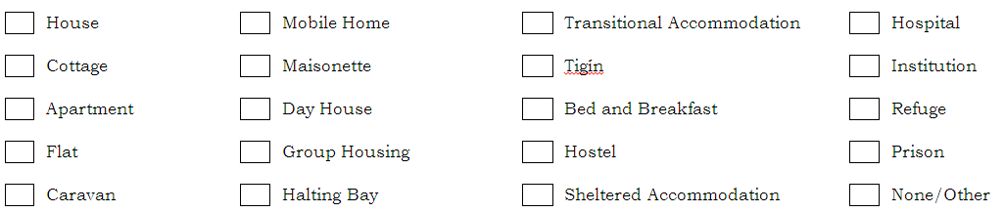
What facilities do you have in your current accommodation? (please tick the boxes which apply)
How many bedrooms are there in your current property? (please write in number)
Do you share some rooms with another household i.e. persons not on this form? (please tick)
If so, please write in what rooms you have to share.

Q 6. Other property/land (please write in the following or tick where indicated)
Do you or any member of the household own property or land in Ireland or any other country? (please tick)
If so, does this include a residential property which is vacant?
Address of the property or land owned (please write in)

Q 7. Local Connection
Local Connection - please indicate if any of the following applies to your household (tick)
- The household lived in the area for 5 years or more in the past
- Someone in the household works in or near the area
- Someone in the household goes to full-time education in the area

- A relative resides in the area and has resided there for over 2 years.
- Someone in the household with a disability or medical condition attends related services and/or facilities in the area

DECLARATION
Once you have finished filling out this form, please read this declaration
carefully and sign and date it.
Collection and Use of Data
The housing authority will use the data which you have supplied to administer your housing application. Data may be shared with other public bodies for the purpose of the prevention or detection of fraud. The housing authority may, in conjunction with the Department of the Environment, Community & Local Government, process this data for research purposes including forward planning in relation to the assessment of housing needs.
The housing authority may, for the purpose of its functions under the Housing Acts of 1966 - 2009, request and obtain information from another housing authority, the Criminal Assets Bureau, An Garda Síochána, The Department for Social Protection, the Health Service Executive [HSE] or an approved housing body, in relation to occupants or prospective occupants of, or applicants for, local authority housing, and any other person the authority considers may be engaged in anti-social behaviour.

Declaration
I/We declare that the information and particulars given by me/us on this form are true and correct.
I/We undertake to notify the housing authority of any change in my/our household circumstances (e.g. address, household composition, employment, medical conditions etc.)
I/We also authorise the housing authority to make whatever enquiries it considers necessary to verify details on my/our application.

Signature of Main Applicant
Print full name (BLOCK CAPITALS)
Signature of Joint Applicant
Print full name (BLOCK CAPITALS)
Date (dd/mm/yy)

DOCUMENTS REQUIRED
- These may apply to you if your circumstances have changed recently/since you applied or since you last updated your information with the Council.
- We may need you to submit further documentation and we will tell you about this as quickly as possible if needed.
For all households | - Proof of current address (e.g. a bill, copy of tenancy agreement)
Any new household members (e.g. new babies) | - Birth Certificate
Any recent Marriages or Civil Partnerships | - Marriage/Civil Partnership certificate
Any household member in employment | - Latest P60  - The last 6 payslips
Any household member in self-employment | - 2 years of accounts
Any household members in receipt of social welfare | - Information from the Department of Social Protection on current social welfare payments (payment names and amounts)
Any household member who is a non-EEA national | - A copy of the latest GNIB card  - A copy of the latest Stamp endorsement on the passport
Any recent legal separation or divorce | - Copy of the agreement
Any recent custody arrangement | - Document which sets out the arrangements
Any recent maintenance arrangements | - Document which sets out how much maintenance is received

