Conservation and Architects Report
Proposed development
66 Upper Georges Street Dún Laoghaire Co Dublin
December 2016

Scope of the works  Dún Laoghaire-Rathdown County proposes to  refurbish an existing building with its division  into four apartments on the first and second  floors and one commercial unit on the ground  floor at Park House, 66 Upper Georges Street,  Dún Laoghaire, Co. Dublin, (this site is located  within an Architectural Conservation Area):-  The building adjoins the People’s Park and would have been constructed between 1880-1900  Proposed Accommodation  SHOP COMMERCIAL USE AREA 186 SQM  APARTMENT NO 1 1 BED 56SQM  NO 2 66 SQM  NO 3 73 SQM  NO 4 77 SQM  Existing Site / use  The site area is 205 sqm  The existing building has been used as a residence  and more recently as an office and the ground  floor has been in continuous commercial use as an office and shop. | 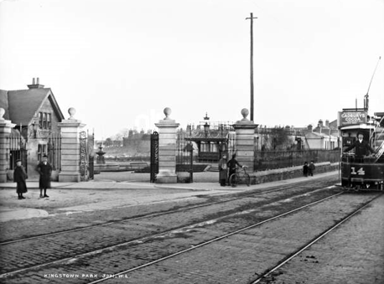  View of the People’s Park opposite
Description of the Existing building  The original building was three storey over  basement ( to the front only) built in red brick with a slate roof with substantial chimneys. It formed part of the street elevation to the Main Street. It turns the corner from Georges Street to Park Road. It overlooks the Park.  Additions  The back section of the plan opening onto the back Lane which was originally a Yard or back garden. The back garden was  closed in at a later date, with a flat roof and external walls with a plaster  finish, in poor quality construction.  A first floor room was constructed on this roof with access to the roof as a "roof garden "  There is a first and second floor, largely sanitary extension, also in poor quality construction, again with a plaster finish.  Proposed Development  The proposal is to provide four apartments for tenants off the housing list, The apartments numbers one and three to the front, will be one bed units. Their main living space will have views of the Park. There is no outside space for these  apartments but they will be able to use the adjoining Park. They also have a storage space at ground level for bicycles and bins.  Apartments numbered two and four will be two bed units with balconies with Park and Sea views.  The  elevation to the Park illustrates how these  apartments step down towards the sea.  They also are provided with ground floor storage.  Access to the apartments is from a new entrance door from Georges Street and a new stairwell to the first floor.  All front doors to the apartments  open off this hallway. The apartments are  located above the ground floor, which will be  retained as a commercial/ shop unit.  The basement is of low height and not suitable for commercial or residential use. The existing access to the basement at ground floor will be retained as it allows access to the existing drainage.  Shop /commercial unit  The shop is accessed from Georges Street and  Park Road. There is a "shop window" to both  elevations.  The site slopes in the direction of the sea so there is a change in level of six steps between the front and back of the shop.  This unit will be managed by the local authority.  Conservation Report  History and importance  The existing building dates from the late 19th century when the People's Park was laid out to a design by John Loftus Robinson  It was constructed as a three storey over basement property , a commercial ground floor with living above.  This was typical of this period  The 1901 census lists five persons, family name Murdoch operating a hardware store with three servants. They were all living over the shop.  Proposed works  The poor quality later extensions will be demolished and re built to meet current Building Standards.  The new elements will be distinguished by highquality finishes metal roofing and glazed railings to the balcony areas.  The building is not a protected structure but it lieswithin an Architectural Conservation Area and works must be undertaken to the exterior in accordance with the ACA.  The ACA Haigh Terrace to Park Road states in Sections 5-7 guidance on roofs walls and boundary treatments.  Roof  The existing slate roof will be refurbished with  matching slates. The flat roofs are in poor condition allowing water ingress into the building. These will be removed and replaced as shown.  New roofs will be high quality metal finish  Walls  The existing red brick walls will be retained restored and repointed in lime mortar  Rainwater goods  On the original building the rainwater goods are in poor repair allowing water ingress and they will be repaired and replaced as required to match existing goods.  The rwp discharging onto the front elevation  Is causing water ingress on the top floor.  Windows  The original Windows have been replaced in the late 20th c with white aluminium windows and these will be replaced with timber framed Windows, sash windows to the upper floor. | 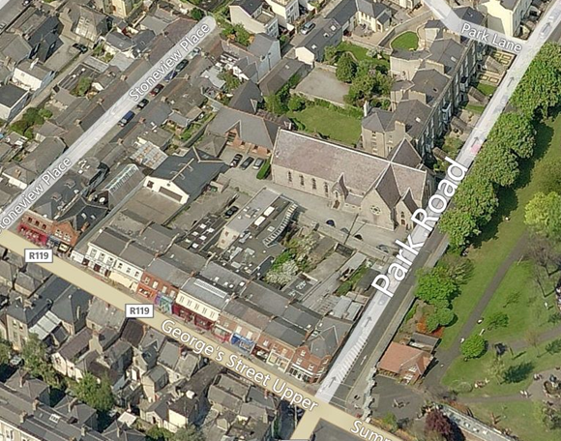  Ariel view terrace layout  Current photograph note buddleia growth on rwp  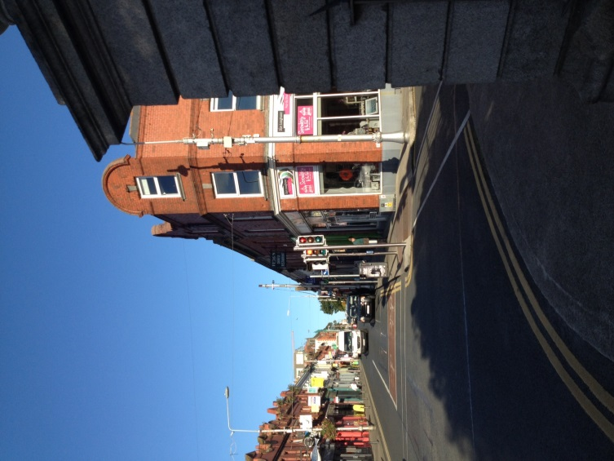  View from entrance to People’s Park  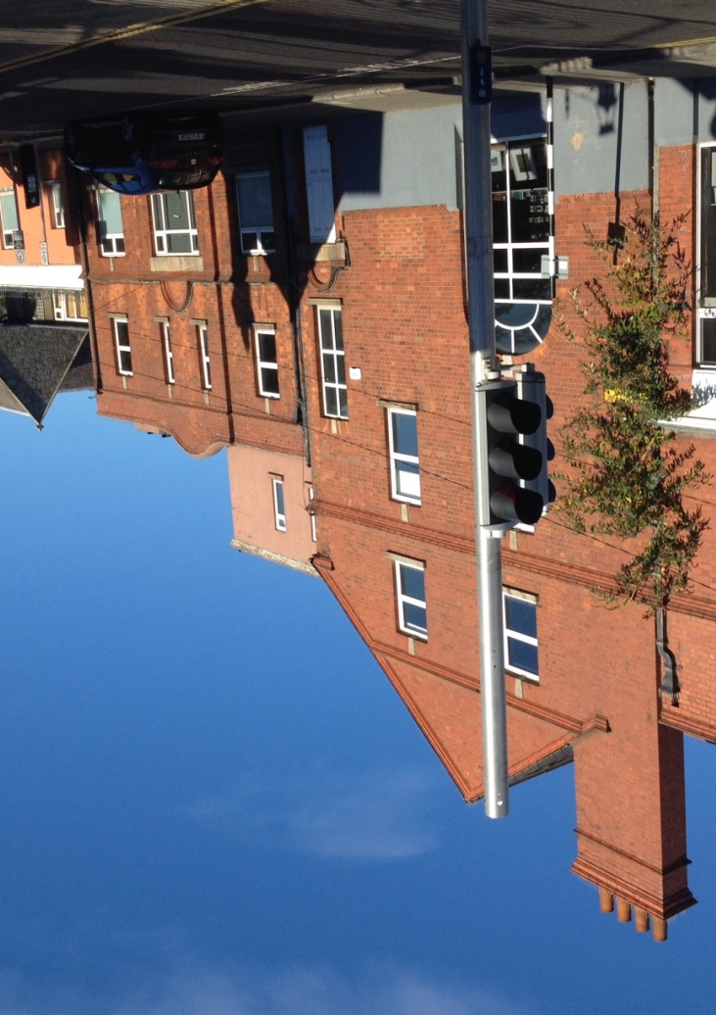  Park Road view  View Upper Georges Street Elevation

