**SOCIO-ECONOMIC STATEMENT FOR DÚN LAOGHAIRE-RATHDOWN**

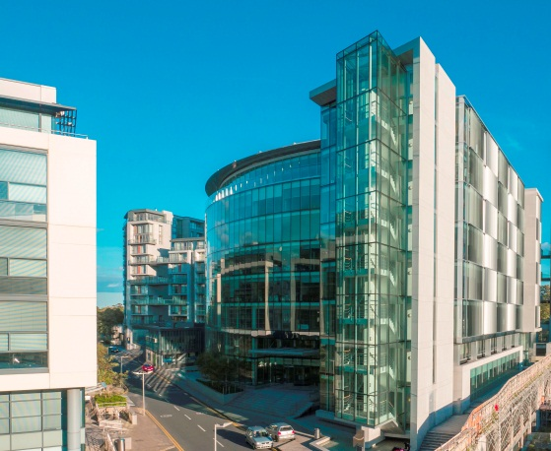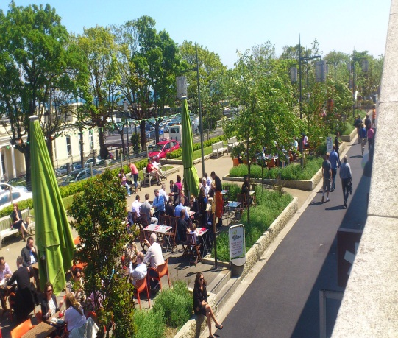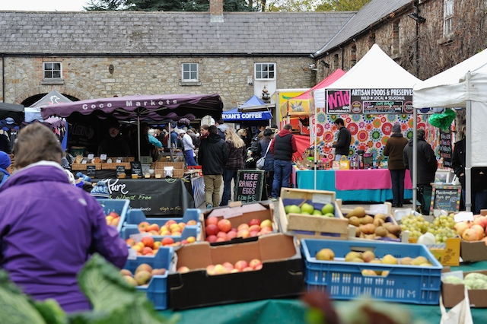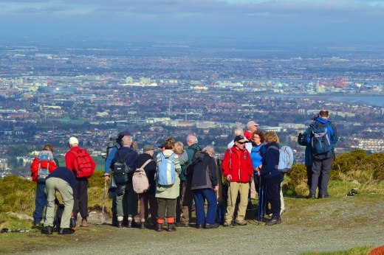

TABLE OF CONTENTS

INTRODUCTION 1

LOCAL ECONOMIC AND COMMUNITY PLAN VISION 1

HIGH LEVEL GOALS FOR DÚN LAOGHAIRE-RATHDOWN 2

DÚN LAOGHAIRE-RATHDOWN SOCIO-ECONOMIC ANALYSIS HIGHLIGHTS 4

ECONOMIC AND COMMUNITY SWOT ANALYSIS 5

OBJECTIVES FROM HIGH LEVEL GOALS 6

NEXT STEPS IN THE PROCESS 8

ABOUT THE DÚN LAOGHAIRE-RATHDOWN LECP PLAN 9

# INTRODUCTION

Dún Laoghaire-Rathdown County Council is in the process of developing a Local Economic and Community Plan (LECP) which will identify goals, objectives and actions that will promote and support the economic and community development of Dún Laoghaire-Rathdown over the next 6 years. It will affect everyone who lives, works, does business, invests and visits Dún Laoghaire-Rathdown. This Socio-Economic Statement is designed to facilitate you to have your say on the development of our county.

The Socio-Economic Statement is an integral part of the development of the LECP for Dún Laoghaire-Rathdown. The LECP is also consistent with the County Development Plan for Dún Laoghaire-Rathdown, and with government policy at national and regional levels, including the Government’s Action Plan for Jobs and Enterprise strategy, and the Further Education and Training Strategy. Based on socio-economic research and analysis of the County, this Socio-Economic Statement sets out high level goals for the LECP, with the purpose of promoting well-being, economic development and quality of life in Dún Laoghaire-Rathdown. We are seeking your views on this Socio-Economic Statement and the feedback and submissions that we receive as part of the consultation phase on the Socio-Economic Statement will inform the development of the LECP.

Contributions from the public are vitally important to ensure the final LECP reflects the concerns and aspirations of those who live, work and visit the County.

*The views of the public will ultimately influence and inform the development of the LECP for Dún Laoghaire-Rathdown*

In developing this Statement, Dún Laoghaire-Rathdown County Council seeks to identify what are the most important issues to the public, local communities and businesses and other stakeholders both now and over the lifetime of the LECP, which will extend to 2021. Through this process, Dún Laoghaire-Rathdown County Council seeks to create a strong and inclusive county with a shared vision to promote economic and community development, contributing positively to the well-being of all.

We invite you to comment on this document from **Wednesday 20th May 2015 to Tuesday 16th June 2015 inclusive**. Submissions must be received in writing by email or post before 5pm on **Tuesday 16th June 2015 to either:** [**lecp@dlrcoco.ie**](mailto:lecp@dlrcoco.ie)or Dún Laoghaire-Rathdown County Council, Local Economic and Community Plan, County Hall, Marine Road, Dún Laoghaire, Co. Dublin.

Please note that as part of this public consultation, individuals and organisations will be free to make a written submission and highlight relevant issues to us at the public meetings that will be held, and where this option is exercised, both contributions will be considered in the development of the LECP.

# LOCAL ECONOMIC AND COMMUNITY PLAN VISION

Through consultation within Dún Laoghaire-Rathdown County Council, the Local Community Development Committee and the Economic Development and Enterprise Strategic Policy Committee, a vision for the LECP has been developed to translate the county’s ambition in the area of socio-economic development into a clear direction for action over the coming 6 years.

**VISION -**

**“*Dún Laoghaire-Rathdown will build on our strengths as a smart, vibrant county to expand economic activity and employment and to ensure the county is attractive and inclusive, to create a better future for all its communities*”.**

# HIGH LEVEL GOALS FOR DÚN LAOGHAIRE-RATHDOWN

This vision has been used to establish a series of **High Level Goals** to frame the direction and priorities of the LECP**.**

The **High Level Goals** provide priority areas for the future development of the County which aims to provide a high quality of life and well-being to all who live, work, do business, invest in and visit Dún Laoghaire-Rathdown.

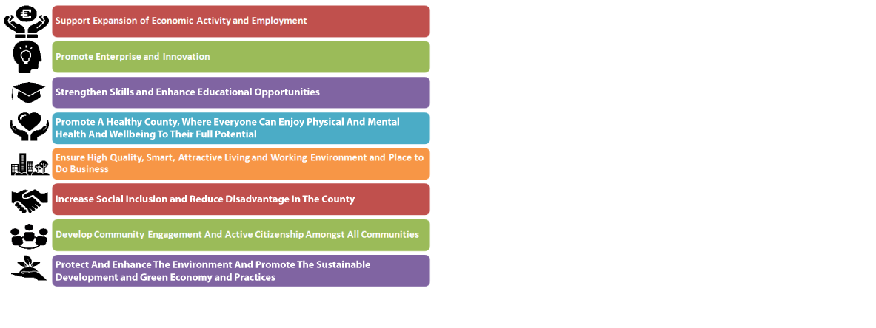

The high level goals set out in the final Statement will be developed into a series of objectives and targeted measurable actions that will provide the focus to measure how the goals are achieved.

From the high level goals, a series of objectives is also developed. These objectives relate to economic development goals, to community development goals or as objectives that combine both economic and community development aspects.



# DÚN LAOGHAIRE-RATHDOWN SOCIO-ECONOMIC ANALYSIS HIGHLIGHTS

**Socio-Economic Base**

* Population in DLR has grown by 6.3% between 2006 and 2011 census. This is the second lowest growth rate in the Greater Dublin Area (GDA)
* 14.5% of the population are aged 65 years and over which is higher than the Dublin and national average
* 12.2% of the population of the county are non-Irish nationals
* DLR has a labour force participation rate of 58%, the lowest rate in the Greater Dublin Area
* 49.5% of those aged 15 years and older in DLR have a third level qualification, the highest rate nationally
* DLR includes areas of high socio-economic deprivation
* DLR has a total age dependency ratio of 49 which is the highest ratio in Dublin
* DLR has a youth dependency ratio of 27 which is below the GDA average and an elderly dependency ratio of 22 which is by far the highest in the GDA
* 56% of the labour force in DLR is composed of professional, managerial and technical workers. This is by some margin the highest percentage in the GDA
* 35% of the labour force in DLR commute to jobs within DLR. 44% of employment in DLR is by DLR residents
* 56% of employment in DLR is by non-DLR residents. The main areas from which people commute to DLR are Dublin City and South Dublin

**Economic Base**

* Commerce and Trade accounts for 37% of employment in DLR by broad industry classification. Professional services account for 25% of employment in DLR
* DLR has 389 Enterprise Ireland supported companies. The majority of these companies operate in business and consumer services, enterprise software solutions and life sciences and clean tech sectors
* These Enterprise Ireland supported companies provide 7,651 jobs
* DLR contains 38 IDA client companies. These companies represent significant foreign direct investment in DLR
* These IDA companies primarily operate in the financial services, software, ICT and medical devices sectors
* 2% of all industrial units in Ireland are also located in DLR
* Latest available data indicates that industrial value added in DLR in 2009 was €1.9 billion

**Social and Economic Infrastructure**

* 25,123 people in DLR have a disability of which 41.4% (10,398) are aged 65 years and over, which is the 6th highest by population across counties in Ireland
* 7,930 people provide regular, unpaid help to a family member or friend with a disability, long-term illness or health problem
* DLR contains 66,800 houses and 15,300 apartments; 19.9% of households live in apartments, flats or bedsits
* 5.9% of households (4,444 households) live in social housing (Local Authority and Housing Association)
* 6.6% of housing in DLR is Social Housing and this rate is lower than the Dublin and national average
* In 19.7% of families living in DLR, the oldest child is aged between 0-9 years
* DLR is also well served by road transport links with good M50 access and by public transportation with the DART and Luas, as well as number of bus routes, providing links to Dublin city centre
* Travelling to work by car accounts for 54.2% of all journeys, making car travel the most common means of commuting to work
* Dún Laoghaire harbour plans to attract additional cruise passengers over the coming years with a target of 100,000 passengers and crew arriving in the harbour in 2015
* DLR contains several third level and further education institutions including UCD, IADT, Smurfit Business School, the Dún Laoghaire College of Further Education and the Irish Management Institute, amongst others.

# ECONOMIC AND COMMUNITY SWOT ANALYSIS

The socio-economic analysis has analysed a number of key strengths as well as weaknesses of the County, and has identified the implications of these in terms of opportunities and also threats which will be addressed in the LECP. A summary of these are presented in the table below.

**DÚN LAOGHAIRE-RATHDOWN ECONOMY AND COMMUNITY – SWOT ANALYSIS**

|  |  |  |  |
| --- | --- | --- | --- |
| **STRENGTHS** | **WEAKNESSES** | **OPPORTUNITIES** | **THREATS** |
| * Well educated and highly skilled labour force * Relatively large number of IDA and Enterprise Ireland supported firms focused on international traded markets * Industrial activity in DLR produces relatively high value added products * Well served for transport infrastructure. M50, DART, Luas * Excellent access to educational facilities including important third level colleges * Coastal county with a major harbour represents opportunities to build on marine sector * Established town centre retail and service sector * Attractive towns and villages combined with coastal and mountain physical assets represent strengths both for community and for tourism | * DLR is experiencing relatively low population growth relative to other parts of the GDA * DLR has a relatively high elderly dependency ratio compared to the rest of the GDA * The labour force participation rate in DLR is relatively low compared to both the national average and the average in the rest of the GDA * DLR includes areas of high socio-economic deprivation * Limited public transport linkages between east and west of DLR | * Relatively high office vacancy rate provides scope for region to benefit as economy continues to improve * Large amount of FDI and indigenous export firms in region has potential to take advantage of agglomeration effects in attracting additional investment and in encouraging expansion of existing base * Excellent transport links and highly educated labour force continue to make the area an attractive investment site for Irish and international business * Physical attractiveness of county and infrastructure provide opportunities for expansion in tourism * Skill and educational profile provides opportunity for county to build on its existing strengths as a smart vibrant location | * FDI and indigenous export firms represent large employers in the region. If county does not retain its competitive advantages for such activity this could mean major job losses should investment pull out or if scale of projects decline * Continued decline in retail trade may have negative impact on town centres as community hubs and sources of employment in the region * Rising house prices and a relative shortage in supply make the region less attractive which will reduce population growth and further contribute to the elderly dependency rate in the region * The benefits of an economic expansion could bypass some of our community unless socio economic gaps are addressed |

# OBJECTIVES FROM HIGH LEVEL GOALS

In order to achieve the high level goals we have proposed a number of specific objectives under economic elements, shared community and economic elements, and community elements. These are set out below.

**ECONOMIC ELEMENTS: SPECIFIC OBJECTIVES**

* **ATTRACT NEW INVESTMENT IN INTERNATIONALLY TRADED BUSINESSES, IN NEW START UPS, GREEN ECONOMY OPPORTUNITIES, INTERNATIONAL SERVICES AND HIGH TECH SECTORS**
* **FACILITATE INNOVATION AND EXPANSION OF EXISTING MANUFACTURING AND SERVICES ENTERPRISES**
* **REALISE POTENTIAL OF TOURISM, RECREATION AND CULTURE SECTORS**
* **DEVELOP AN ENTERPRISE FRIENDLY ENVIRONMENT IN THE COUNTY**

**SHARED ECONOMIC AND COMMUNITY ELEMENTS: SPECIFIC OBJECTIVES**

* **SUPPORT LIFE-LONG LEARNING, ENTERPRISE DEVELOPMENT AND STRENGTHEN EMPLOYMENT IN LOCAL COMMUNITIES**
* **SUPPORT LOCALLY-BASED CREATIVE AND KNOWLEDGE ENTERPRISES AND STRENGTHEN UP-SKILLING WITHIN THE COUNTY**
* **PROVIDE FAMILIES WITH SUPPORT AND ACCESS TO EARLY CHILDCARE SERVICES, SUPPORT WORKING FAMILIES ATTAIN A BETTER QUALITY OF LIFE AND REMOVE POTENTIAL BARRIERS TO EMPLOYMENT**
* **PROMOTE AND IMPROVE THE PROSPERITY OF TOWN CENTRES AND RETAIL CENTRES**
* **TO INCREASE THE LEVEL OF PHILANTHROPY IN DÚN LAOGHAIRE RATHDOWN AND TO EXPAND THE COMMUNITY OF ENGAGED DONORS WHO ARE REGULAR, STRATEGIC, LONG-TERM CONTRIBUTORS TO GOOD CAUSES**
* **IT IS AN OBJECTIVE THAT ALL COMMUNITIES HAVE ACCESS TO A FULL RANGE OF SERVICES AND AMENITIES TO ENSURE A GOOD QUALITY OF LIFE, INCLUDING A DWELLING OF GOOD QUALITY, AT AFFORDABLE LEVELS, SUITED TO NEEDS, IN A GOOD ENVIRONMENT AND, AS FAR AS POSSIBLE, AT THE TENURE OF CHOICE.**
* **PROTECT THE NATURAL AND BUILT ENVIRONMENT FOR THE CURRENT AND FUTURE GENERATION THROUGH THE PROTECTION AND PRESERVATION OF LOCAL BIODIVERSITY AND CULTURAL HERITAGE; THE PROMOTION OF ENVIRONMENTAL AWARENESS; THE ENHANCEMENT OF RESOURCE EFFICIENCY AND THE PROMOTION OF SMART, SUSTAINABLE ENERGY STRUCTURES, TECHNOLOGIES AND PRACTICES.**

**COMMUNITY ELEMENTS: SPECIFIC OBJECTIVES**

* **DEVELOP A SUPPORTIVE ENVIRONMENT AND PROMOTE HEALTHY LIFESTYLE CHOICES SO THAT EVERYONE, REGARDLESS OF ABILITY, EDUCATION OR INCOME HAS THE OPPORTUNITY FOR BETTER PHYSICAL AND MENTAL HEALTH AND WELL-BEING, THROUGH ACCESS TO COMMUNITY SERVICES, AMENITIES, SPORTS, RECREATION AND A HIGH QUALITY PUBLIC REALM.**
* **IT IS AN OBJECTIVE THAT ALL WITHIN THE COUNTY FEEL SAFE AND SECURE AS THEY GO ABOUT THEIR DAILY LIVES.**
* **DEVELOP CAPACITY BUILDING WITHIN COMMUNITIES TO CREATE IMPROVED SUPPORT FOR INDIVIDUALS AND COMMUNITY ORGANISATIONS, ENABLING THEM TO MEET THE NEEDS OF THEIR AREAS MORE EFFECTIVELY.**
* **SUPPORT MARGINALISED COMMUNITIES THROUGH THE COLLABORATION WITH LOCAL COMMUNITIES AND AGENCIES TO REDUCE SOCIAL EXCLUSION AND POVERTY, AND VALUING CULTURAL DIVERSITY.**
* **DEVELOP AND ENCOURAGE CIVIC ENGAGEMENT AND STEWARDSHIP AND SUPPORT STRUCTURES WHICH ALLOW GREATER COMMUNITY DEVELOPMENT.**

# NEXT STEPS IN THE PROCESS

This Socio-Economic Statement represents the first step of the Local Economic and Community Plan (LECP) as it suggests high level goals which will form the foundation for the economic and community development of the area over the coming years.

We invite you to comment on this document from **Wednesday 20th May 2015 to Tuesday 16th June 2015 inclusive**. Submissions must be received in writing by email or post before 5pm on **Tuesday 16th June 2015 to either:** [**lecp@dlrcoco.ie**](mailto:lecp@dlrcoco.ie)or Dún Laoghaire-Rathdown County Council, Local Economic and Community Plan, County Hall, Marine Road, Dún Laoghaire, Co. Dublin.

The participation and contribution of local community, children and families, businesses and other organisations is critical to the development and overall success of the LECP. Members of the public are encouraged to make submissions regarding this socio-economic statement to identify the important economic and community issues for the county and how these should evolve.

The main features of the overall Dún Laoghaire-Rathdown LECP will consist of:

* High level *goals* for the integrated plan,
* Supported by specific *objectives* under the respective economic and community streams
* A series of *actions* which will be established to achieve the objectives within the economic and community elements of the plan.

The actions will be both time-bound and measurable to oversee the delivery of the objectives. The LECP will be completed by the end of 2015, and will guide the economic and community development of the county over the next six-years.

# ABOUT THE DÚN LAOGHAIRE-RATHDOWN LECP PLAN

Across the country, local authorities are emerging as key drivers for stimulating and enabling enterprise and innovation in local areas. Recent and ongoing alignment processes have resulted in an expanded role for local authorities, beyond their traditional functions and now includes economic and community development and promotion in collaboration with other agencies.

Recent changes involve the integration of the Local Enterprise Office (LEO) within local authorities, as well as the establishment of Local Community Development Committees (LCDCs) along with Economic Development and Enterprise Strategic Policy Committees (SPC) in each local authority area. These two committees are charged with responsibility to develop an integrated Local Economic and Community Plan (LECP) for each county.

The Local Government Reform Act 2014 provides a stronger and clearer role for local government in economic and community development by placing local government as the “...main vehicle of governance and public service at local level, leading economic, social and community development”. The Act also provides for the development of a Local Economic and Community Plan (LECP) to cover a six-year period by each Local Authority.

Dún Laoghaire-Rathdown County Council is currently in the process of developing a LECP which must identify goals, objectives and actions that will promote and support the economic and community development of Dún Laoghaire-Rathdown. It will affect everyone who lives, works, does business, invests and visits Dún Laoghaire-Rathdown. The Council will coordinate the development of the LECP in partnership with an extensive number of other economic and community stakeholders. The LECP will be the framework for the economic and community development of our county for the next six years and will also be the primary mechanism, at local level, to bring forward relevant actions arising under the various relevant regional and national plans and strategies such as the Action Plan for Jobs.

This document, the Socio-Economic Statement, is a vital component of the development of a Local Economic and Community Plan for Dún Laoghaire-Rathdown. This Socio-Economic Statement is part of the consultation process to facilitate you to have your say on the development of our county and here are some key details, which set the context for our county.

This document was produced by Dún Laoghaire-Rathdown County Council in conjunction with Indecon Economic Consultants and Future Analytics Consultants for the Dún Laoghaire-Rathdown Strategic Policy Committee on Economic and Enterprise Development and for the Dún Laoghaire-Rathdown Local Community Development Committee.