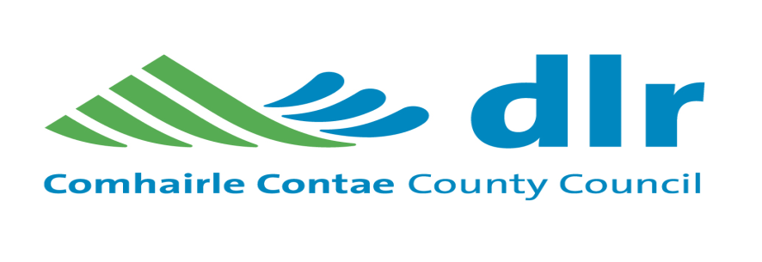
Stillorgan Village Movement Framework Plan

Public Consultation Information Period

Dún Laoghaire-Rathdown County Council is currently preparing a Movement Framework Plan for the Stillorgan Village.
The Purpose of Movement Framework Plan is:-
- To provide improvements to the Public Realm, which when combined with inventive planning by private Developers/Businesses will ensure and sustain a rich and vibrant Stillorgan Village.
- To develop a place where people living and working in Stillorgan can move around within a network of safe, pleasant and well connected streets, civic spaces, green links and benefit from an improved environment around the village core.
- To provide for an increase in walking, cycling and safer access to Public Transport.
Purpose of this Consultation Period is to invite submissions from the public and allow interested parties and individuals to view the Council’s proposals and “Have Their Say”.
Copies of the proposals will be available for inspection during normal office hours from Wednesday 28th October until Wednesday 9th December 2015 at the Stillorgan Shopping Centre (Corridor on First Floor), Stillorgan Library.
Copies of the proposals are also available on the Citizens Space section of the Councils website at dlrcoco.citizenspace.com.
Submissions and observations may be made in writing to:
Senior Engineer, Transportation Traffic, County Hall, Marine Road, Dún Laoghaire, Co. Dublin or by email to traffic@dlrcoco.ie, marked “Stillorgan Village Area Movement Framework Plan”.
The closing date for receipt of submissions is Wednesday 9th December 2015.

